La Puna
  - Volume 2 | Issue 1
July, 2023

Newsletter
‘If I could tell the story in words I wouldn’t need to lug around a camera.’
Lewis Hine
My trip to Argentina almost closes a circle which began during the Ballarat International Foto Biennale in 2015. At that point I was a third-year student at Photograph Studies College and I was the Volunteer Coordinator for the Biennale.
I went into the former Backspace Gallery to check on a volunteer and immediately fell in love with a photograph there. It had the most incredible landscape – rock formations that were twisted, colourful and harsh. In the foreground was a large flock of flamingos, diminutive because of the distance from the photographer. I had to buy it and it still hangs in my house today. It has never lost its impact. This began my friendship with its creator, Silvi Glattauer.
I made a decision. If I ever had the chance to go to that place to take photographs, then I would take it.
I also harboured a secret ambition to have my work exhibited in the Art Gallery of Ballarat. It would be a marker for an undergraduate student that the quality of my work had progressed.
And so, we come to this point – my Neverlasting Exhibition. To be held during the 2023 Ballarat International Foto Biennale where I will show images from my trip to the La Puna region of Argentina and the works will hang in the Backspace Gallery of the Art Gallery of Ballarat.
The Puna region is like no other place I have ever been. Situated in the north-west of Argentina, it is a vast alpine plateau above the clouds. The plains, at the lowest point, are between 3,000-3500 metres above sea level. The mountains and volcanoes that run along its sides rise to 6,500 metres.
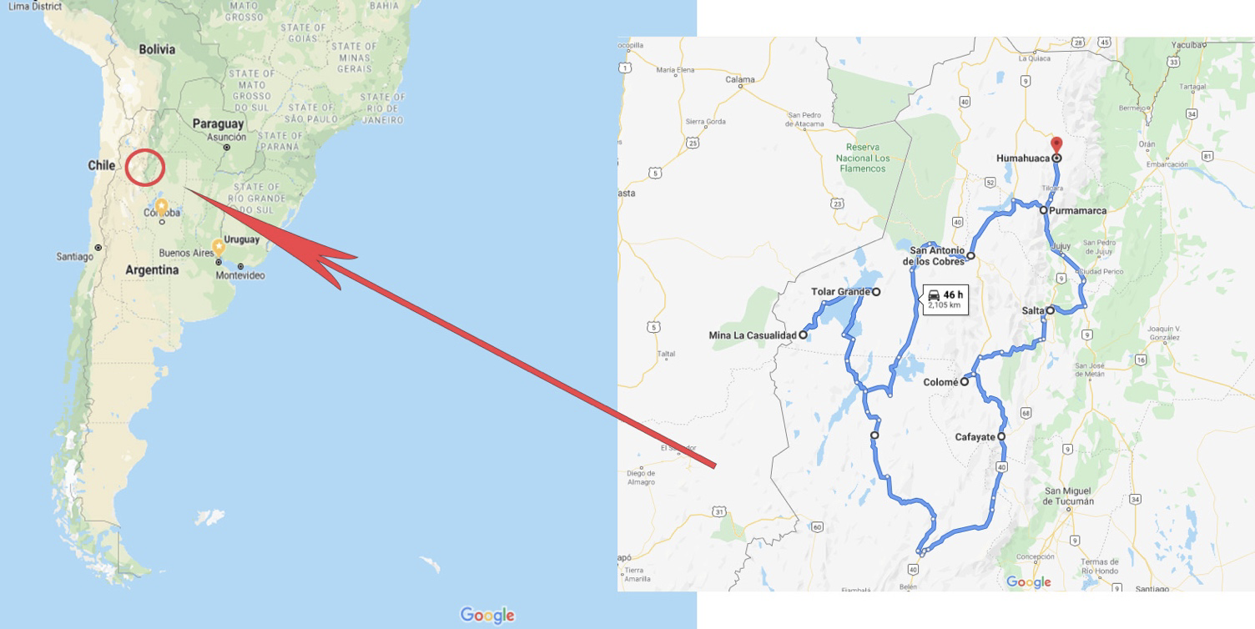

It is as place without trees. What grows here must be tough and tenacious. Winters are dry here but very cold (-20C). There is a saying here that if you survive August here you will live another year. Apart from the cold, the winds in that month are ferocious, capable of blowing out car windows.
And yet humans inhabit the place. Indigenous peoples such as the Quilmes who chose to make it their home for over 600 years before they were conquered by the Incas, and shortly after that by the Spanish.
The scale of the place astounds. Open plains, volcanic cones, twisted layers of rock, pumice deserts, salt flats and dunes. All of this is painted with the carefully crafted muted tones as if from an artist’s palette. Villages are small and far apart. We were travelling 300-400 kms each day.
The difficulty for an artist is to show the vastness of the place. How do you convey that size, that sense of isolation?
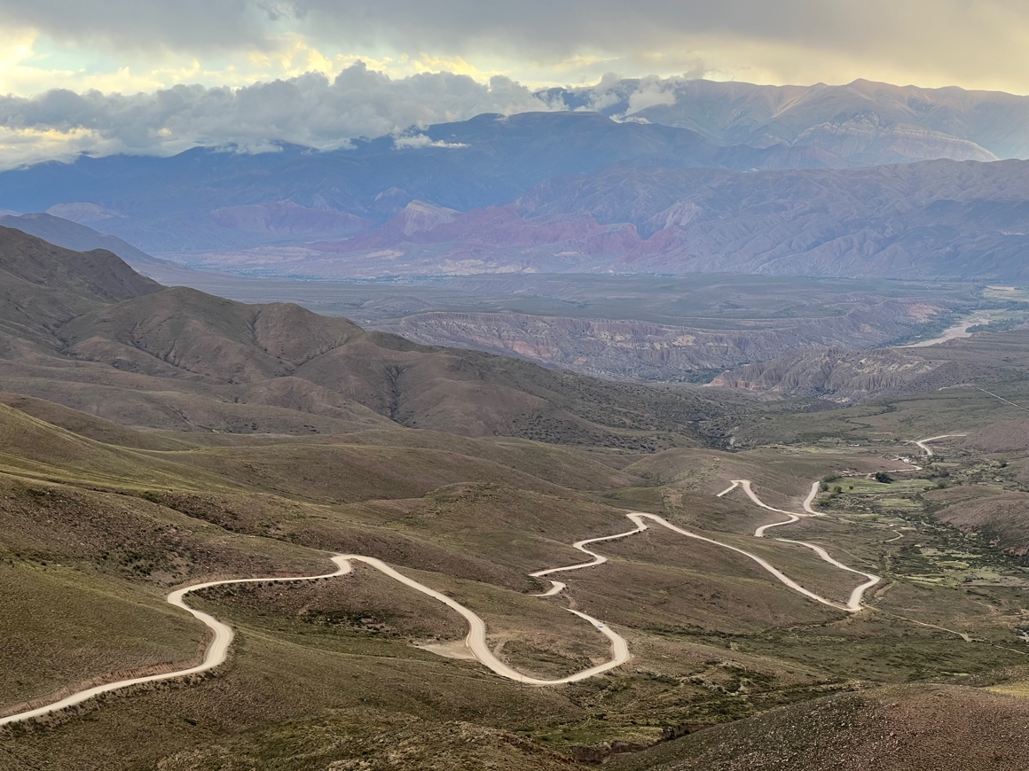
The road ascending into the altiplano region.

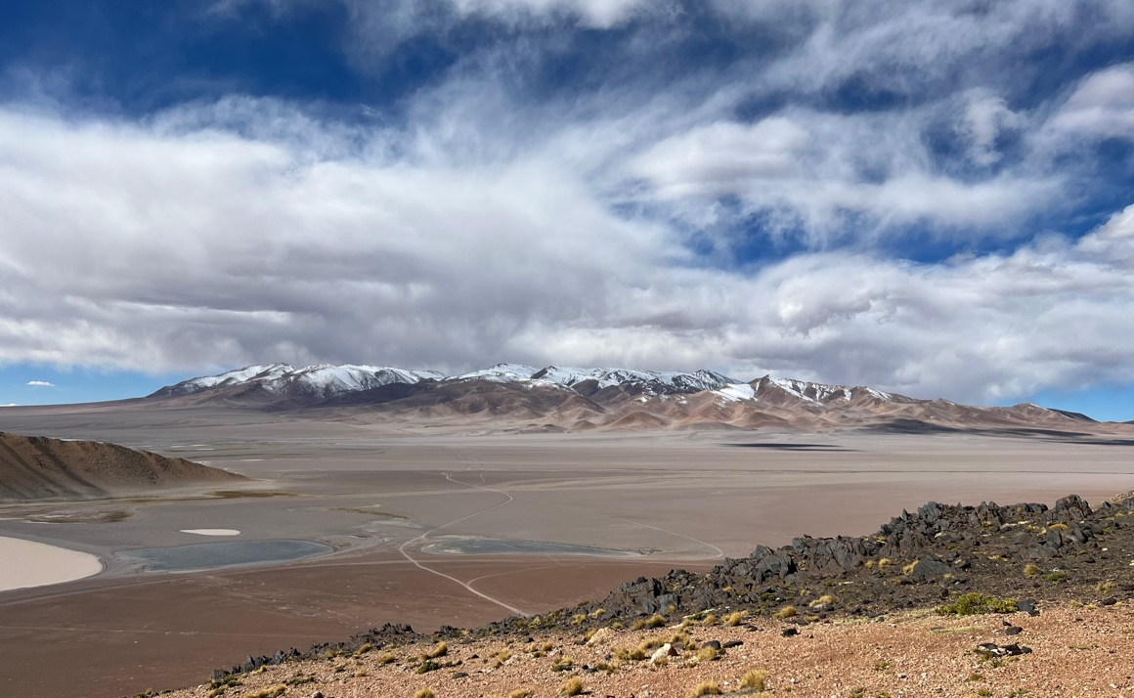
The La Puna region is such a vast place.
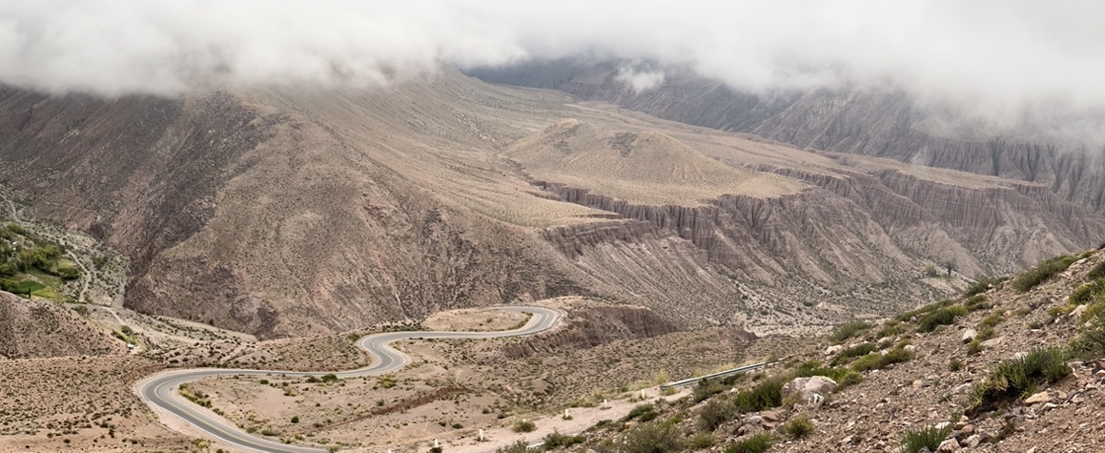
I can assure you that the roads were not always paved, in fact, hardly ever, the cost and maintenance would be prohibitive.
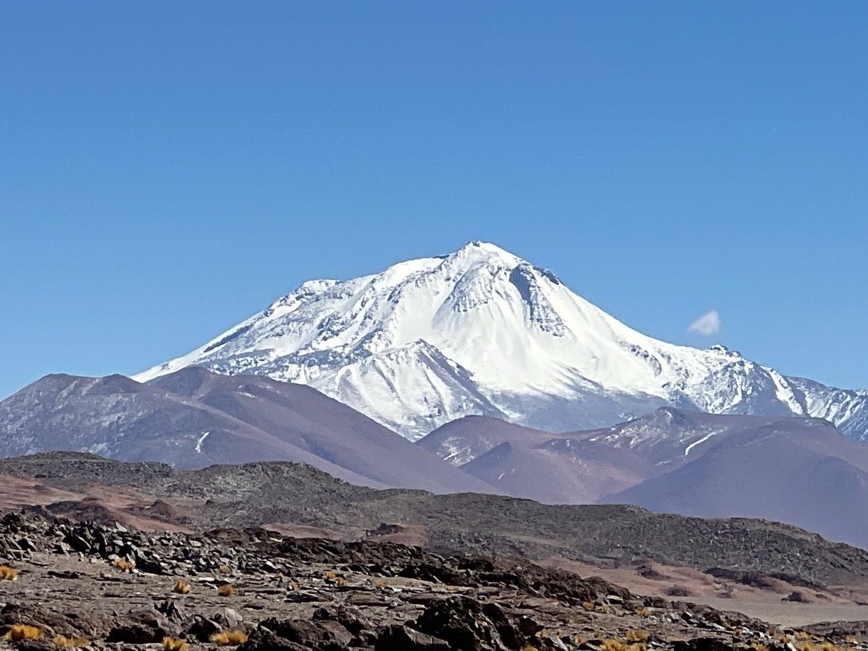
Volcanoes abound. This one, Volcan Llullaillaco, stands at 6,500 metres. The Incas made human sacrifices here and their journey to its peak took three and a half weeks.

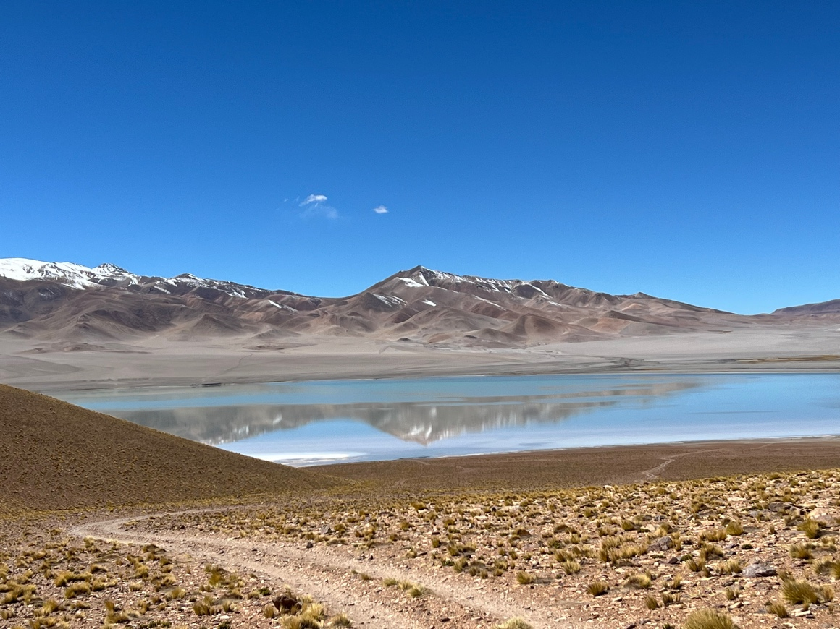
Laguna Diamante, I think this is the most beautiful lake I have ever seen.
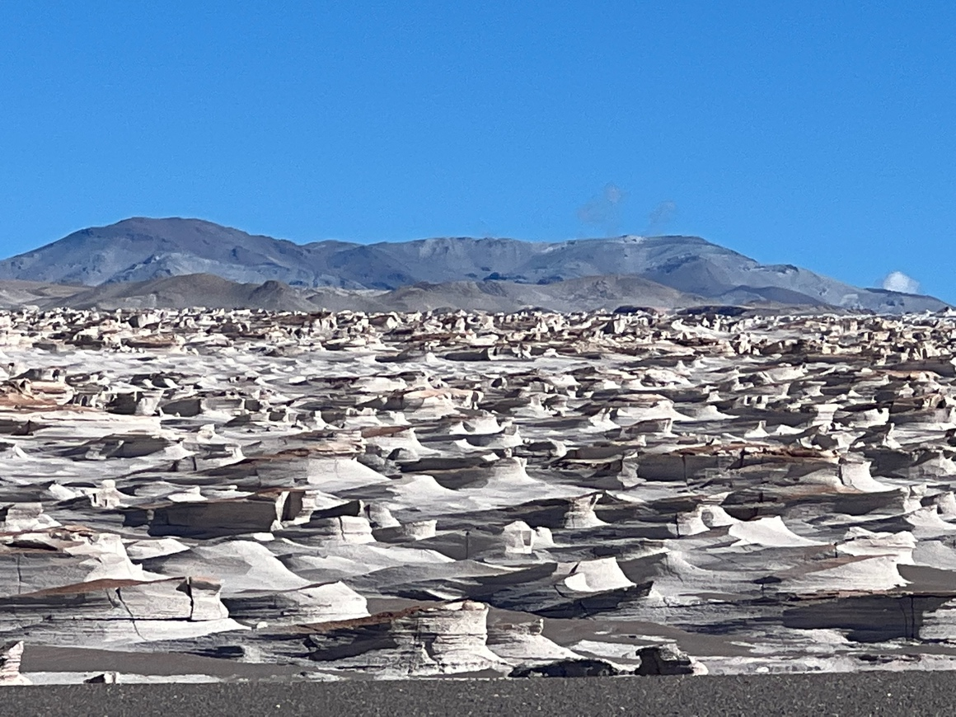
Pumice desert.
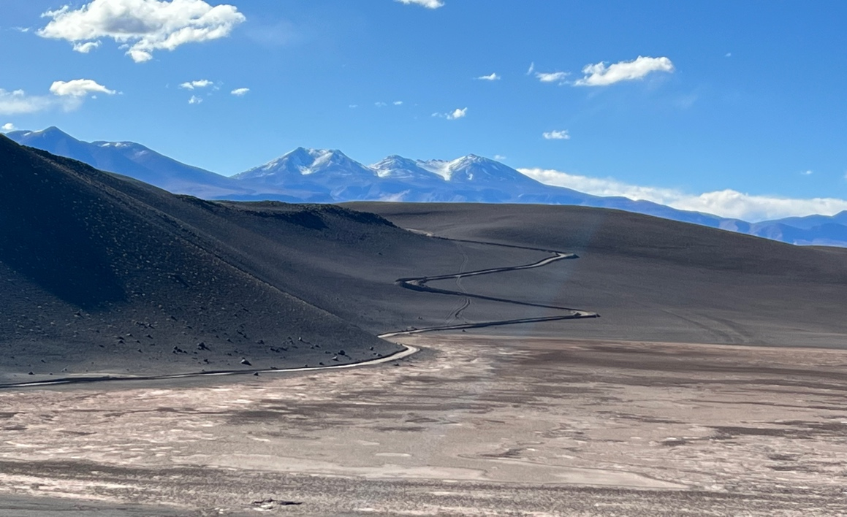
Salt plains.
The images that I have just shown you will give you some idea of where I was. They are the content of my coming exhibitions. The difference will be that I have made them into fine art photographs and photogravure prints. One of the difficulties that I faced was how to reduce the vast number of images that I took into the small number that will be on show. And the selections that I made have to represent my subject of how human life is neverlasting.

Neverlasting Exhibition

Members and friends of the artist are invited to the opening of a Backspace Gallery exhibition of landscape photographs by local photographer Ian Kemp which we are presenting for the Ballarat International Foto Biennale.
For Ballarat-based photographer Ian Kemp, images of the natural world are a metaphor for the transience of human life – its permanence and impermanence. The works in this exhibition capture a changing world where beauty is ephemeral and temporary.
The guest speaker will be Jeff Moorfoot, founder and former Director of the Ballarat International Foto Biennale.
Exhibition dates: 17 August–22 October 2023
Opening event: Friday 18 August, 6 pm–8 pm
Book now HERE

Like No Other Place
During the BIFB I will have some other work exhibited in the Open Program, called Like No Other Place. This work, which has other images from La Puna, will be on display at Mr Jones Dining. I’m pleased to be back here; this is the third Biennale that I have exhibited my work in this wonderful restaurant.

Dates
August 17-October 22

Venue
Mr Jones Dining
42-44 Main Rd, Bakery Hill

Times
Tuesday-Saturday, 12.00 noon – 10.00pm.

Anyone wishing to purchase any of my work during the exhibitions should contact me via my website or email.

Classes: the art of photography

I am beginning my third Art of Photography class in October.

Dates: October 29
November 5, 12,19, 26
December 3
In addition, I will make an appointment with you to assist you to set up your camera and computer prior to the first lesson so that we can get straight into the learning.

Times: 1.00pm-4.00pm

Venue: 205 Seymour St, Soldiers Hill

Requirements: You will need a digital camera, a notebook computer and Lightroom Classic and Photoshop software. If you don’t have this software, then go to the Adobe website and you will find a subscription there for $14.29 per month to give you the latest versions of Lightroom Classic and Photoshop. This is great value as you get all the new upgrades as they are developed.

Cost: $500 to be paid into the following account:
BSB: 063502
A/C # 1095 8743

A $100 deposit will secure your place in the class, with the remainder to be paid prior to the first lesson. Participation will be in order of confirmation with the deposit.

There will be a maximum class size of 4, to give you the best possible instruction.

Let me know if you are interested, or you know someone who might be interested, please get in touch. I am happy to give you more details about the course.

Should you have any questions then please contact me. I will send course work for each lesson prior to the commencement of classes.

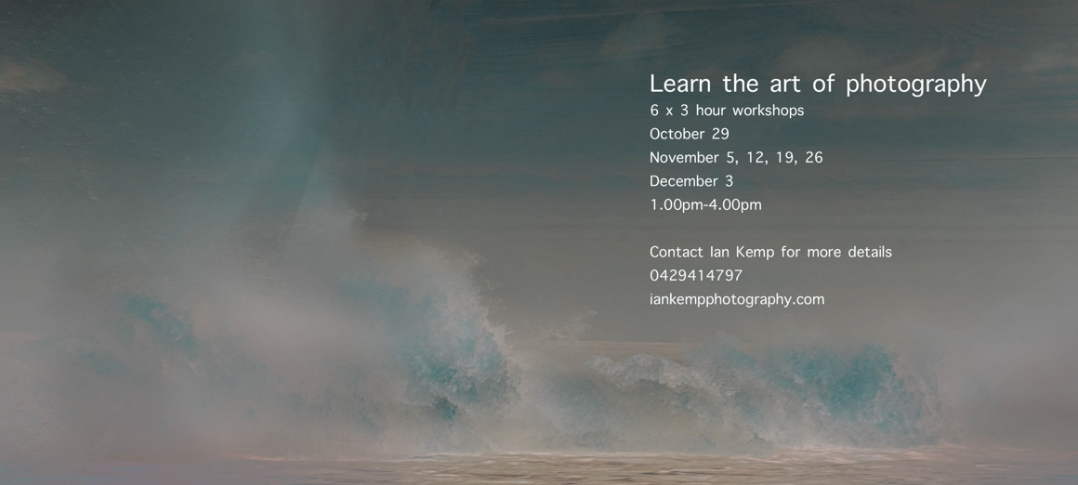

Ian Kemp Photography
205 Seymour St Soldiers Hill, Victoria 3350
0429 414 797
chplains@bigpond.com
www.iankempphotography.com

If you do not wish to receive my newsletter, please email me and I will remove you from my list.

